# Working With An SSH Client

Modern Operating (Microsoft Windows, Apple MacOS and Linux) Systems already have ssh client inbuilt; however there are other ssh applications with added features that offers better experience.

**Windows**

Microsoft Windows does offer ssh which is accessible through Powershell or the CMD.

Users have the alternative of [putty](https://www.putty.org/) and [MobaXterm](https://mobaxterm.mobatek.net/).

**Linux**

Linux offers a command line terminal by default

**MacOS**

MacOS includes a built-in terminal window, there's nothing to install. Just open the terminal app and type your SSH command. The default terminal app doesn't offer many bells and whistles but it gets the job done.

For Robust Terminal experience, Alternative include [Termius](https://termius.com/) and [iTerm2](https://iterm2.com/)

Connect to the login node from the terminal:

Type the following on the command-line

.. codeblock:

ssh [username@allot.hpc.fedgen.net](mailto:username@allot.hpc.fedgen.net)

First time login users will be prompted to change their password. Passwords must adhere to standard complexity requirements.

The more complex the password, the more robust it is against brute force.

If everything worked properly, you should be greeted by a message similar to

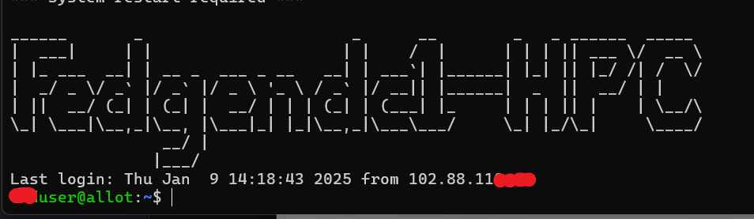

**Note**

Upon your very first connection to each FEDGEN HPC Cluster, you will be greeted by a warning such as:

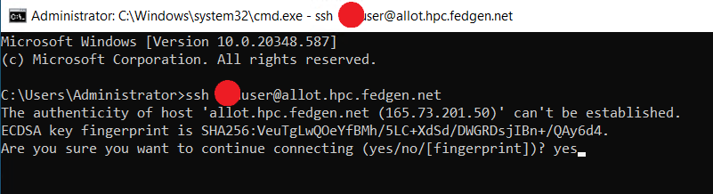

This warning is normal, the SSH program warns that it is the first time it sees this computer. To make sure you are actually connecting to the right machine, you should compare the [RSA key fingerprint](https://en.wikipedia.org/wiki/Public_key_fingerprint) shown in the message with the fingerprint shown in the picture above. The fingerprint can be based on hash function MD5 or SHA-256.

If they match, you are safe to proceed and enter **yes**. That hostname key will be stored and used to check in every subsquent SSH connection that the server is indeed always the same.

[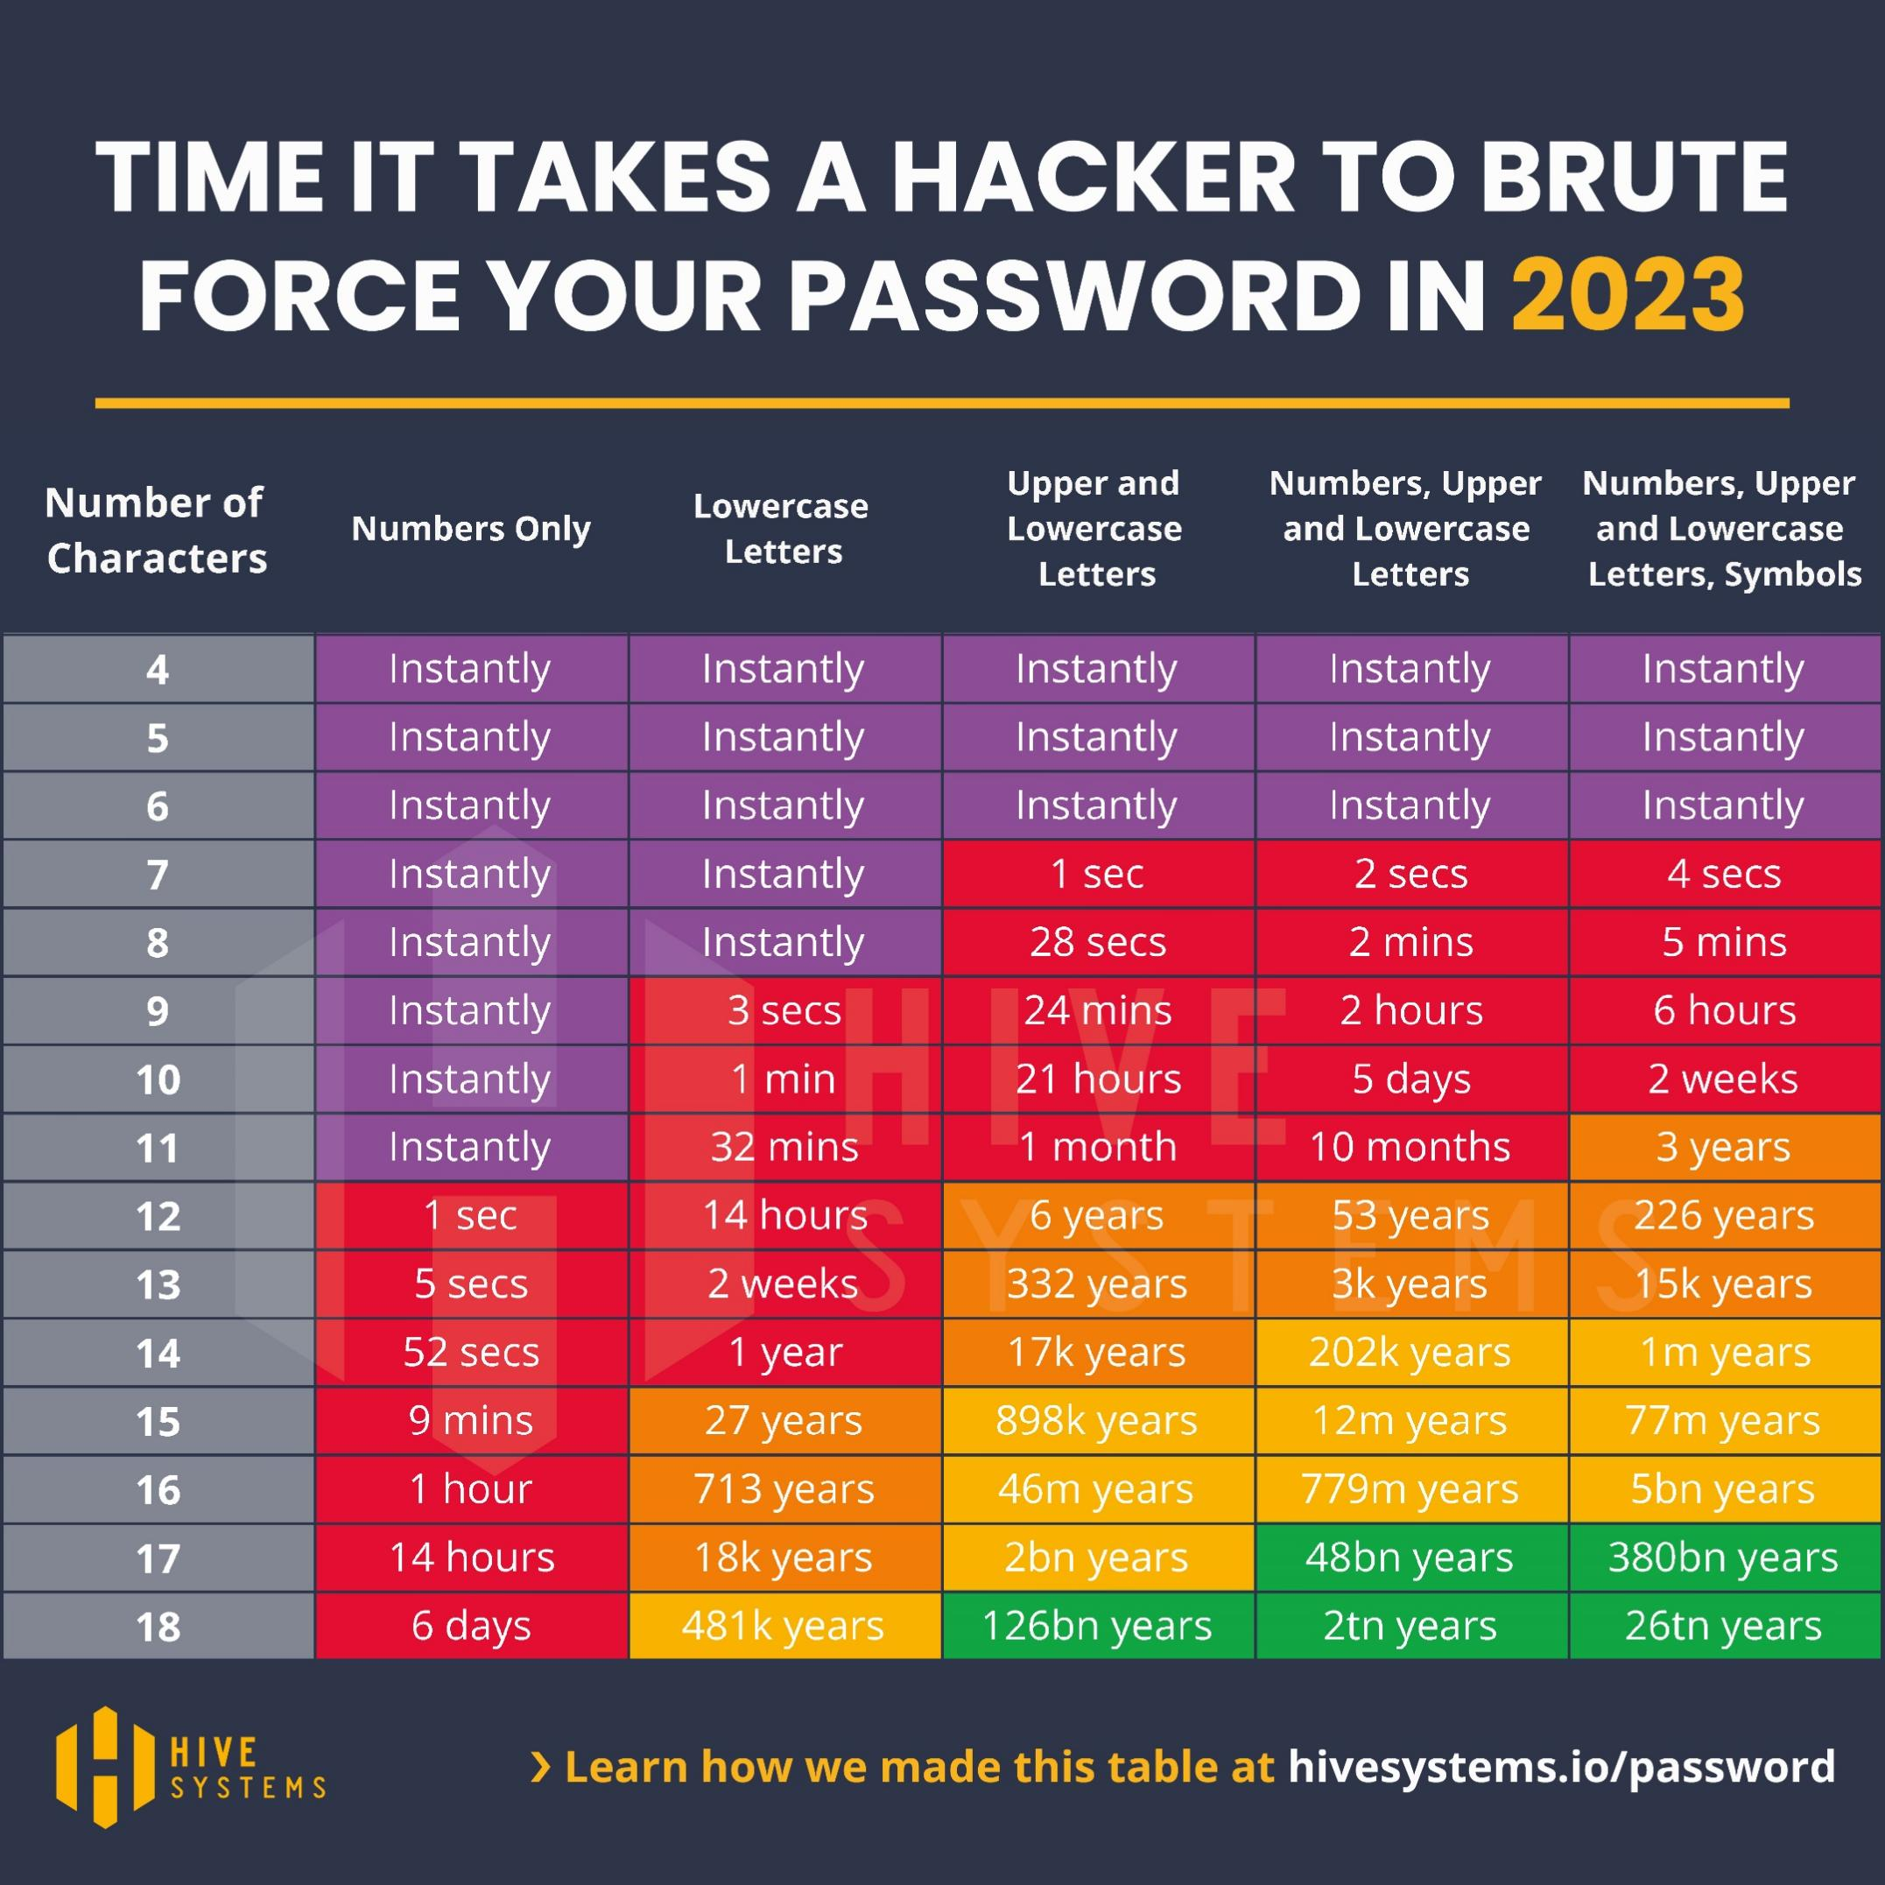](https://si-apc.pages.in2p3.fr/computer-science-crash-course/_images/password-cracking-2023.jpeg)

*Fig. 1*Time to brute force a password in 2023 as a function of length and complexity. Credit: Hive Systems with data sourced from [https://www.hivesystems.io](https://www.hivesystems.io/)

**Exemple of hacked passwords**

|  |  |  |
| --- | --- | --- |
| mt8CIe0Qhh | eisenach! | 123avier123 |
| avier123a12345678910 | Kraz2kriz | alaska2. |
| 12345678910 | 04DI32609 | ag.53yf |
| Kraz2kriz | firebird14 | 04IE69422 |

[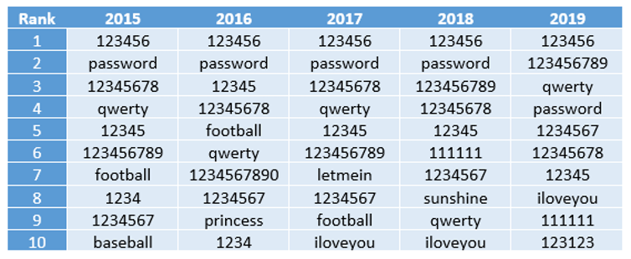](https://si-apc.pages.in2p3.fr/computer-science-crash-course/_images/top-passwords-2015-19.png)

*Fig. 2*The 2019 annual SplashData password survey revealed the most common passwords from 2015 to 2019.